MULEBA INAUGURATION JUNE 19th 2019
The Inaugural Ceremony of a solar-hybrid mini grid at Lake Victoria’s island of Mulumo under the project "Micropower Economy roll-out in Tanzania” commenced with a six hour road trip from the city of Mwanza to the Kagera region of Muleba, followed by a one hour ferry ride to Mulumo island.  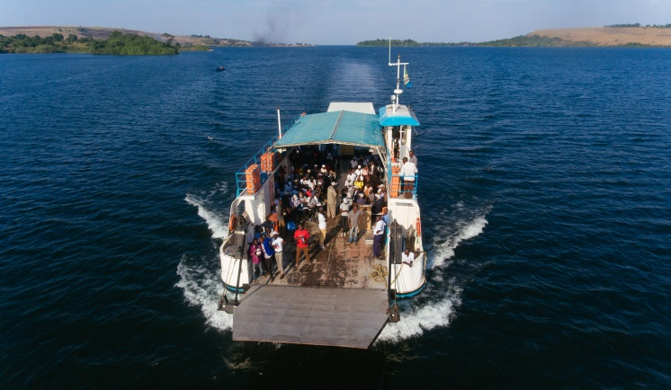  Guests on board ferry to Mulumo | Aerial view of Mulumo village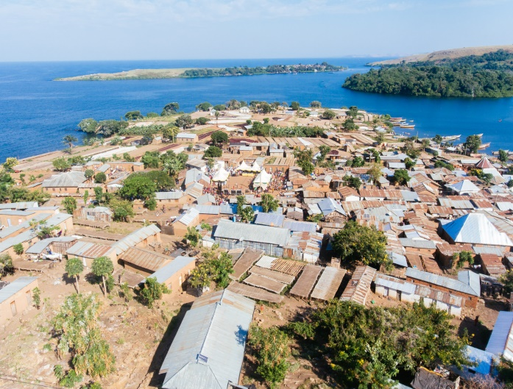
  Guests welcomed to Mulumo by traditional dancers | The over one hundred guests travelling from Bukoba, Dar Es Salaam, Dodoma, and Mwanza were warmly welcomed by the locals with traditional dances at the center stage
The well-organized JUMEME team led by the cluster 2 manager and with the help of the locals then ushered the guests towards the power house for the purposes of showcasing the technology used for electricity production, storage, and distribution in the mini-grid  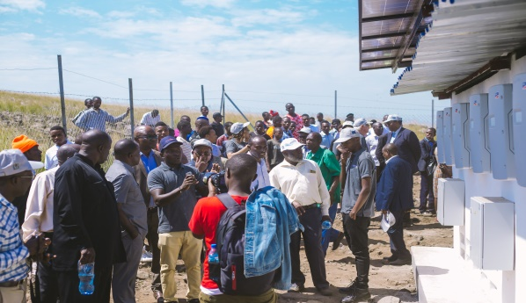  Guests being acquainted with the inverter technology | 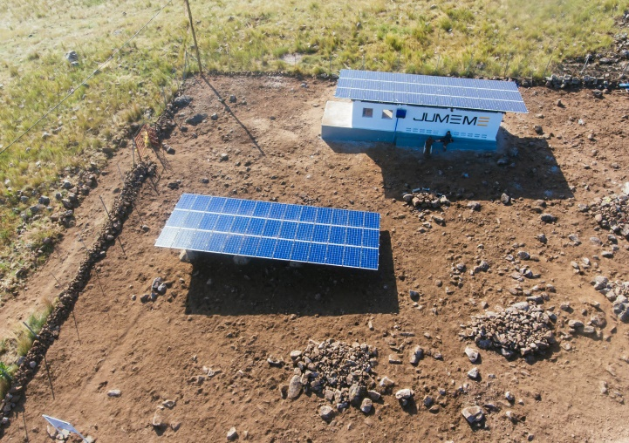  Aerial view of Mulumo power house
After the show case, the guests were then led to the village grounds where the meeting, speeches and dining was to take place. | 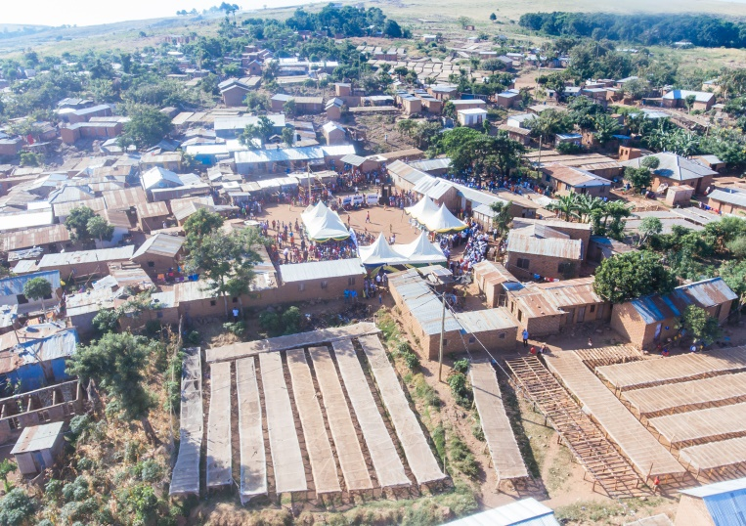  Mulumo village center
The occasion was graced by the presence and speeches from: the representative of the European Delegation in Tanzania who delivered a strong message from the head of the delegation (in absentia) on the use of electricity for development and especially with the inclusion of women; the District Commissioner Ukerewe district who urged the public at Mulumo to take embrace technology and gave some examples of success stories in his district on the island of Ukara; the representatives of the Ministry of Energy and Rural Electrification Agency who showed their gratitude and specially mentioned the difficulty of JUMEME’s project areas with regards to logistics and access; the local leaders who applauded JUMEME for the effort and showed their eagerness in the entire island being electrified; and finally the District Administrative Secretary for the Kagera region in place of the District Commissioner for Muleba who urged the public to work with JUMEME and also emphasized the need for JUMEME to spread its reach further on to the islands. | 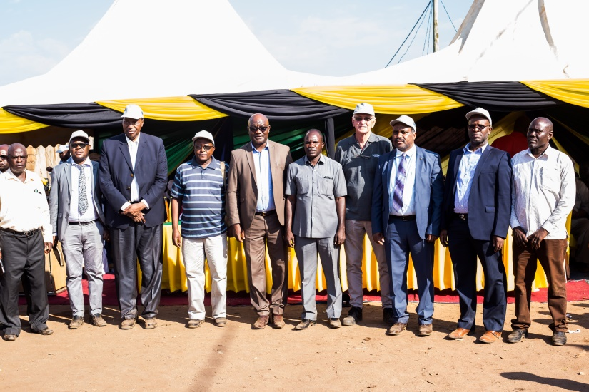  Guests from the E.U; District; St. Augustine University, and the Ministry
The occasion was then graced by a period of sharing a meal for lunch together with the locals and the show case of the KeyMaker business model among other presentations. (Pictures)  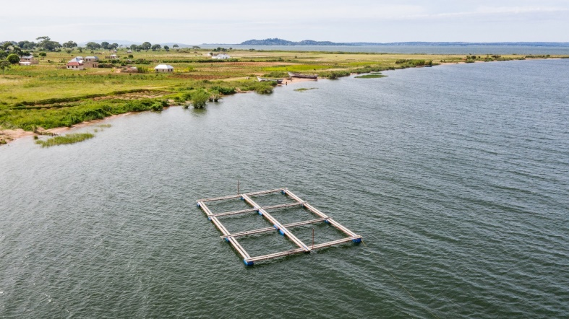  Floating cages in Ukara island | 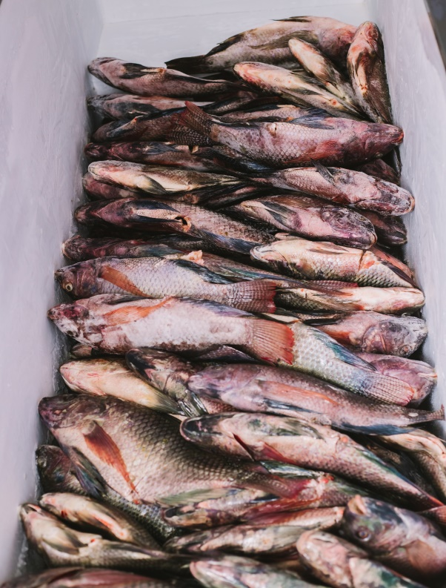  KMM show case in Mulumo

After closing remarks and a vote of thanks from MUMEME’s director (SAUT’s vice Chancellor) the guests then embarked on the journey back to Mwaza and Muleba via ferry and road after a successful day, thanks to the detailed organization from the JUMEME staff both on the ground, in the office, and the support from the directors and shareholders all the way in Europe.

